Name: S. HARATHI

REG No: 192111651

EXP NO: 1 DATE: 28/04/2023

CREATE A SIMPLE CLOUD SOFTWARE APPLICATION AND PROVIDE IT AS A SERVICE USING ANY CLOUD SERVICE PROVIDER TO DEMONSTRATE SOFTWARE AS A SERVICE (SAAS).

AIM:

# To create a simple cloud software application and provide it as a service using it as a service using any cloud service provider to demonstrate Software as a Service (SAAS).

PROCEDURE:

# STEP1: GOTO ZOHO.COM

STEP 2: LOGIN TO THE ZOHO.COM

STEP 3: SELECT ONE APPLICATION

STEP 4: ENTER APPLICATION NAME

STEP 5: CREATE A NEW APPLICATION STEP 6: SELECT ONE FORM

# STEP 7: THE SOFTWARE HASE BEEN CREATED.

IMPLEMENTATION:

STEP1: GOTO ZOHO.COM



STEP 2: LOGIN TO THE ZOHO.COM



STEP 3: SELECT ONE APPLICATION

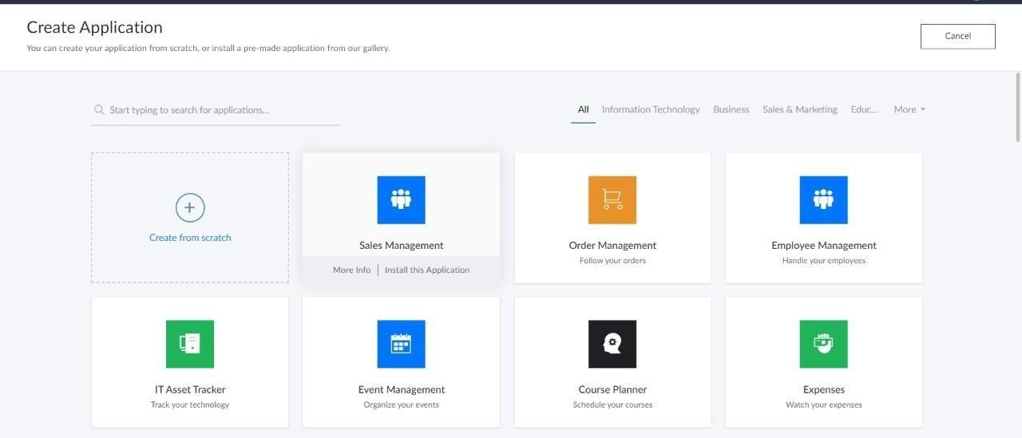

STEP 4: ENTER APPLICATION NAME

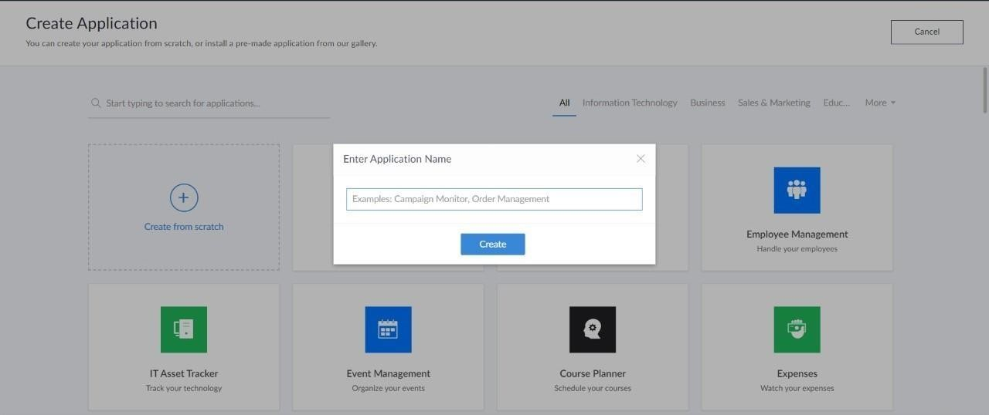

STEP 5: CREATED NEW APPLICATION

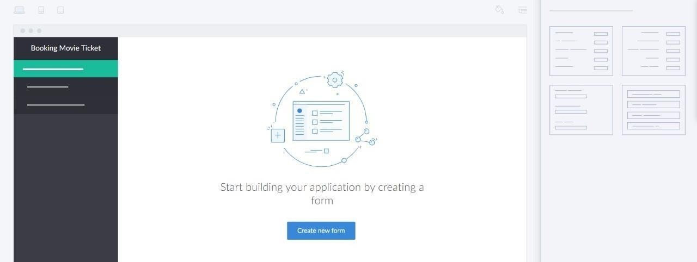

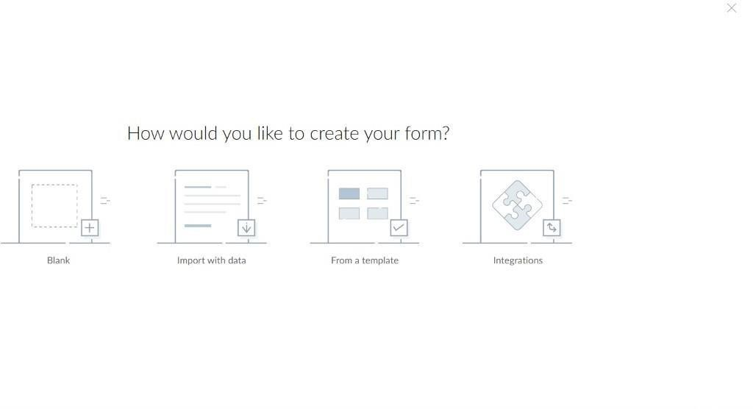STEP 6: SELECT ONE FORM

STEP 7: THE SOFTWARE HASE BEEN CREATED.

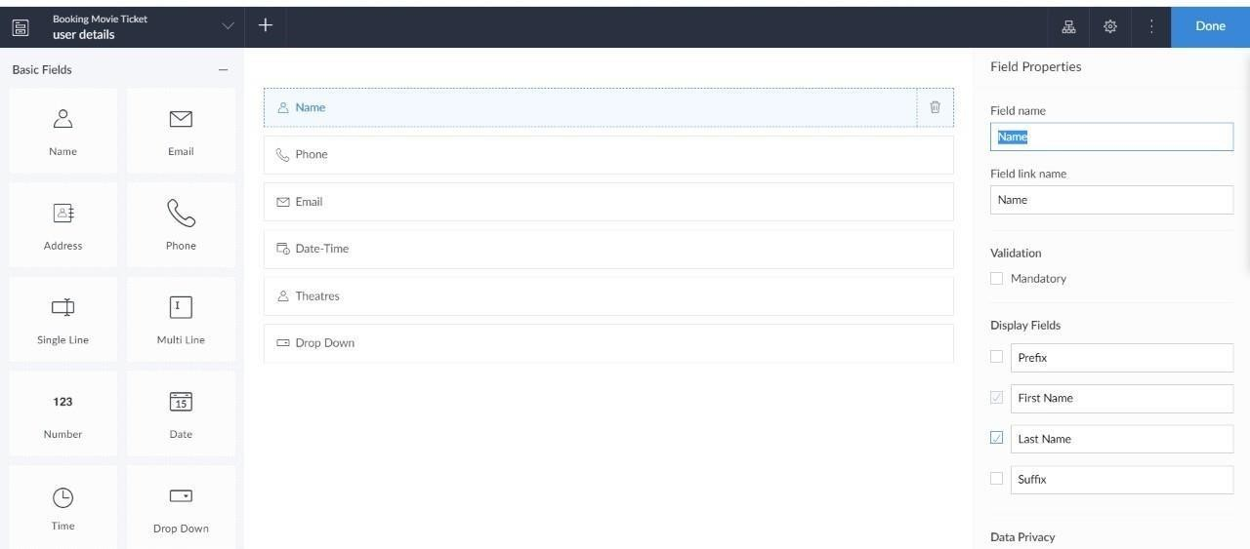

OUTPUT:

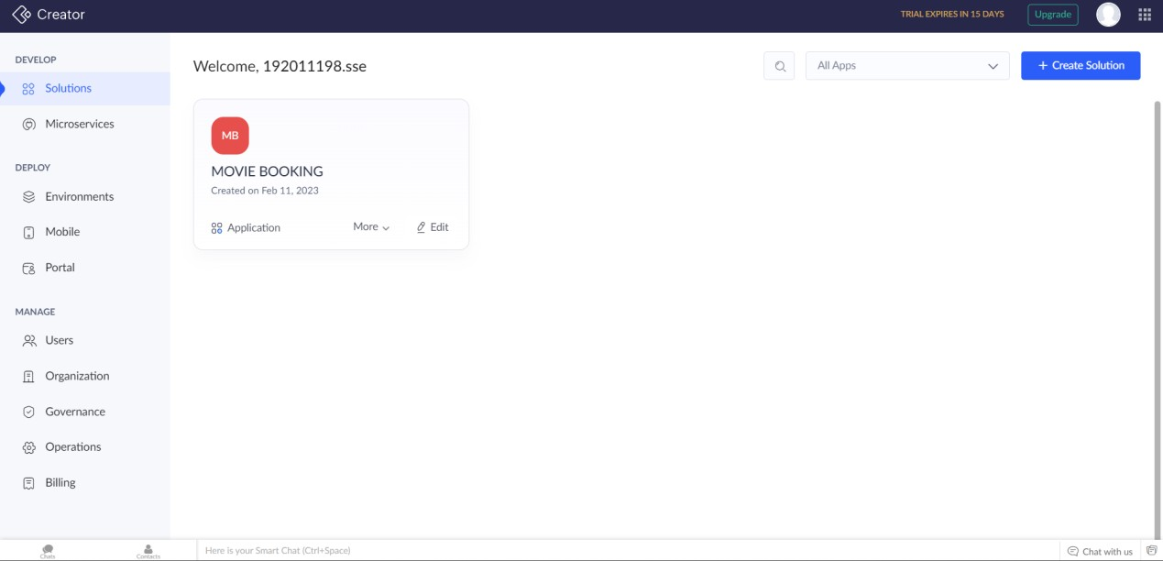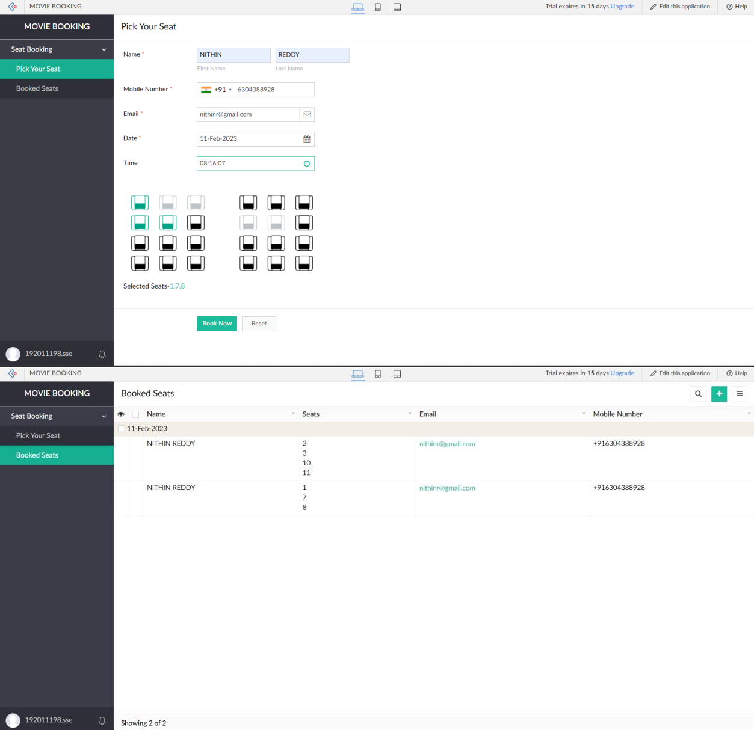

RESULT:

**Hence the Creation of a CREATE A SIMPLE CLOUD SOFTWARE APPLICATION AND PROVIDE IT AS A SERVICE USING ANY CLOUD SERVICE PROVIDER TO DEMONSTRATE SOFTWARE AS**

**A SERVICE is performed sucessfully**